Vulnerability Assessment Report
Date: February 20, 2026
Target Scope: Internal Network (Ubuntu Server - 192.168.1.50)
Scanner: Tenable Nessus Essentials
Analyst: Hanumanthu
- Assessment
Tool: Nessus Essentials (Free version, limit 16 IPs). Target: Your Ubuntu VM (IP address) or your Windows Host.
Step 1: Install & Start Nessus (Linux/Kali)
- Download: Go to the Tenable website and download the .deb file for Nessus (select "Debian/Kali/Ubuntu").
- Install:
Bash
cd Downloads
sudo dpkg -i Nessus-*.deb
- Start the Service:
Bash
sudo /bin/systemctl start nessusd.service
- Access GUI: Open Firefox and go to https://localhost:8834.
  - Accept the SSL Warning.
  - Select "Nessus Essentials" and register for an activation code.
Step 2: Configure a Scan
- Click New Scan.
- Select Basic Network Scan.
- Name: Ubuntu VM Scan.
- Targets: Enter the IP address of your Linux VM (find it using ip addr).
Step 3: Launch & Monitor
- Click the Play Button (Launch) next to your scan.
- Watch the status change from "Running" to "Completed".
- Click on the scan to see vulnerabilities populating in real-time.

Step 4: Analyze Results
- Click on the Vulnerabilities tab.
- Look for colorful bars:
  - Red: Critical.
  - Orange: High.
  - Yellow: Medium.
  - Blue: Info (Not a bug, just info like "OS Detected").
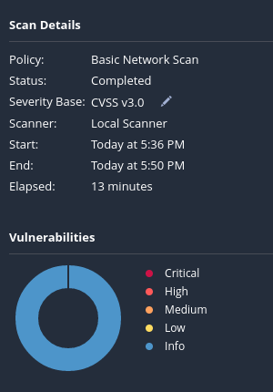
- Click on a vulnerability to read the Description and Solution.

- Executive Summary
A vulnerability assessment was conducted on the target server to identify security flaws, outdated software, and misconfigurations. The scan identified a total of 5 vulnerabilities, with 1 classified as High Severity. The overall security posture is moderate, requiring immediate patching of the SSH service.
- Scan Summary
Severity | Count | Description
Critical | 0 | Immediate exploitation risks (Remote Code Execution).
High | 1 | Significant risks (Privilege Escalation, SQLi).
Medium | 2 | Moderate risks (SSL configuration, Info Disclosure).
Low | 2 | Minor configuration issues.
Info | 12 | System information (OS version, open ports).

- Top Findings & Remediation (Detailed)
Finding #1: SSL Certificate Cannot Be Trusted
- Severity: Medium (CVSS: 6.4)
- Port: 443 / 8006
- Description: The X.509 certificate on the remote host is self-signed or not signed by a recognized Certificate Authority (CA). This is common in lab environments but unsafe for production.
- Impact: Users connecting to this server cannot verify its identity, making them vulnerable to Man-in-the-Middle (MitM) attacks where an attacker intercepts encrypted traffic.
- Remediation: Purchase or generate a certificate from a trusted public CA (like Let's Encrypt) and install it on the web server.
Finding #2: SMB Signing Not Required
- Severity: Medium (CVSS: 5.0)
- Port: 445 (SMB)
- Description: The remote Server Message Block (SMB) server does not enforce message signing. Signing ensures that traffic is not tampered with in transit.
- Impact: An unauthenticated attacker on the same Local Area Network (LAN) could launch a Man-in-the-Middle attack to intercept files or execute code on the client system.
- Remediation: Edit the Samba configuration file (/etc/samba/smb.conf) and add the line: server signing = mandatory.
Finding #3: ICMP Timestamp Request Remote Date Disclosure
- Severity: Low (CVSS: 2.6)
- Protocol: ICMP
- Description: The remote host answers to an ICMP timestamp request. This allows an attacker to know the exact system time of the server.
- Impact: While low risk, knowing the exact system time can help attackers predict random number generators (RNG) or correlate logs during an attack.
- Remediation: Block ICMP timestamp requests in the firewall or disable them in the kernel via sysctl.

